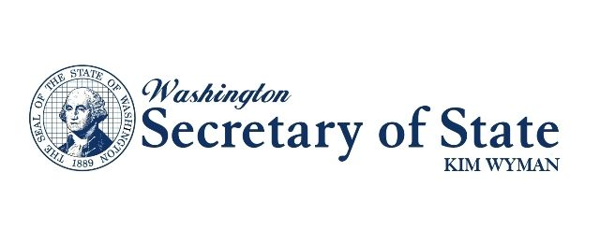 | ARCHIVES RECORDS TRANSMITTAL &  BOX CONTENT LIST  Division of Archives and Records Management
 | Archives  Use Only | Received By | Date | Accession Number

Name of Agency |  |  |  | Office / Sub-Division | Prepared By
Records Coordinator |  |  |  | Records Coordinator Telephone Number |  | Records Coordinator E-mail
Location | Box/ Reel # |  | Record Series / File Title |  |  | Dates |  |  | DAN
Archives Use Only
Transfer of Custody Agreement – Local Government Records Only
(Not Required for State Government and Security Microfilm)

The Office of Record, hereby transfers the records listed above to the custody and jurisdiction of the Washington State Archives with the understanding that the records will become and remain the property of the State of Washington and shall be stored, referenced and managed only in accordance with the laws of the State of Washington, the regulations of the State and Local Records Committees, the policies and procedures of the Division of Archives and Records Management, and the instructions of the State Archivist.

Signed: ______ _ _ Signed: ______ _ _ Official of Office of Record Date Archivist Date

